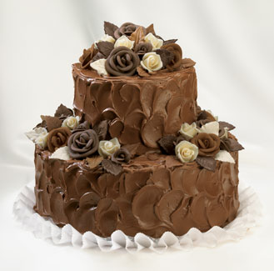
Cooking Multiplication!
Use your multiplication knowledge to solve problems.
Recipe:
This recipe makes a batch of 3 cupcakes
- 150ml natural yogurt
- 3 eggs , beaten
- 1 tsp vanilla extract
- 175g golden caster sugar
- 140g self-raising flour
- 1 tsp baking powder
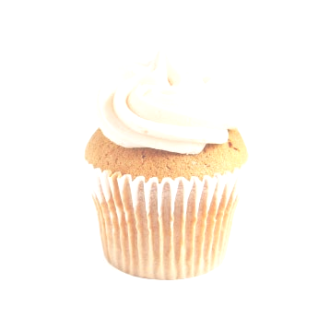
- 100g ground almonds
- 175g unsalted butter , melted
Questions:
Remember to show your workings and include the units in your answer.
- How many eggs would I need if I wanted to make 6 cupcakes?

- How much unsalted butter would I need to make 6 cupcakes?

- How much natural yogurt would I need to make 9 cupcakes?

- How much golden castor sugar would I need to make 9 cupcakes?

- How many teaspoons of vanilla extract would I need to make 6 cupcakes?

- How many eggs would I need to make 9 cupcakes?

- How much self-raising flour would I need to make 2 batches of cupcakes?

