**Y4: Cheetahs Writing Tasks**

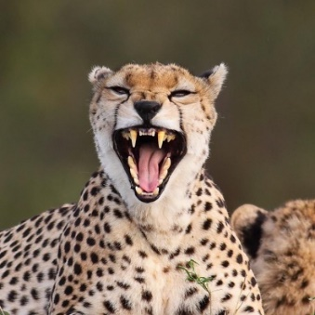Choose one or more of the following writing tasks:

**LETTER**  
If cheetahs and other big cats could speak, what might they want to say to the human race? What might they ask us to do to help them? Using the information you have learned about big cats**, write a letter from a member of the big cat family beginning:**

**Dear Humans,**

**……………………….**

Plan your paragraphs carefully – make a different point in each paragraph.

**STORY**

Do you know Aesop’s Fable about the Lion and the Mouse? You can read a version here: <https://www.bbc.co.uk/teach/school-radio/audio-stories-fables-the-lion-and-the-mouse/zdxxqp3>

Can you write a similar story maybe with a cheetah and a rat as the main characters?

|  |
| --- |
| **Year 4 Writing Checklist**   * Does your writing make sense? * Have you used the correct punctuation including speech marks? * Have you used the correct spelling, especially of common words? * Are the sentences varied in length and do not all begin in the same way? * Have you used some interesting/adventurous words? * Have you avoided unnecessary repetition? * Is the writing clearly organised into paragraphs? * Is the writing in the correct tense? |

**POEM**Write a poem about a cheetah or another member of the big cat family.

The poems below might give you some ideas to get you started.

|  |  |
| --- | --- |
| **O CHEETAH**  O cheetah, you have such sharp claws  and you look so deadly  with your pointy teeth!  You are so fast!  And your darkly dotted coat is very menacing!  Why are your eyes filled with dread?  And why is your coat covered in the blood of war?  I must ask you, how is it you are so fast?  Spill your secrets!  If I ran from you, would I get away?  You must get back to your cubs now.  Run like the wind!  *Henry (Westover Green School)* | **WHITE TIGER**  There is a white tiger in me  with fur like snow  and eyes like a deep green sea  It roars like earthquakes  It prowls like a spy  It lives in my soul  and makes me protective  of those I know,  It makes me want to protect  my heart It makes me feel  like I can be strong.  *Charlotte (Westover Green School)* |