**Year 5 Maths – Multiply by an Integer**

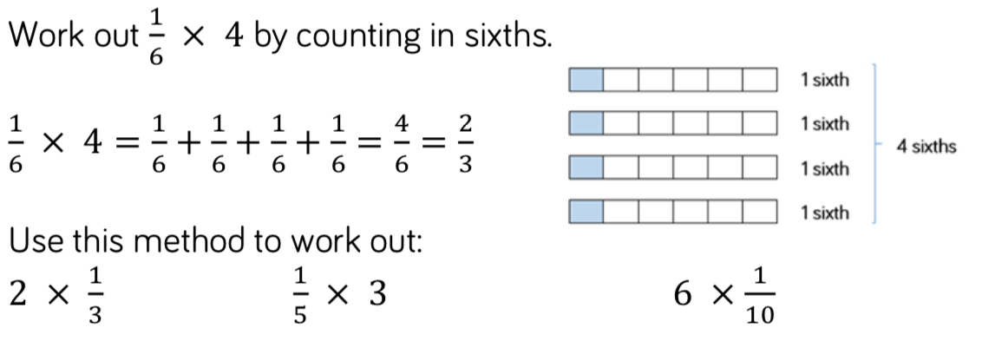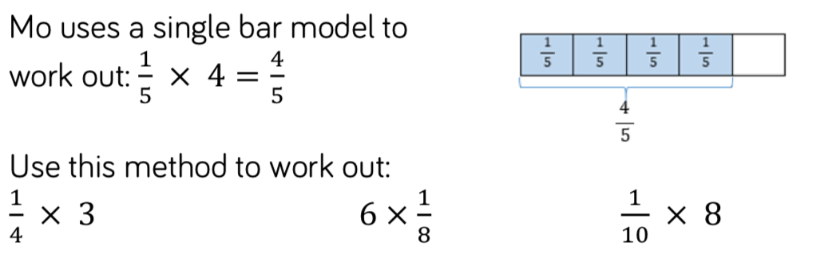**1.**

**2.**

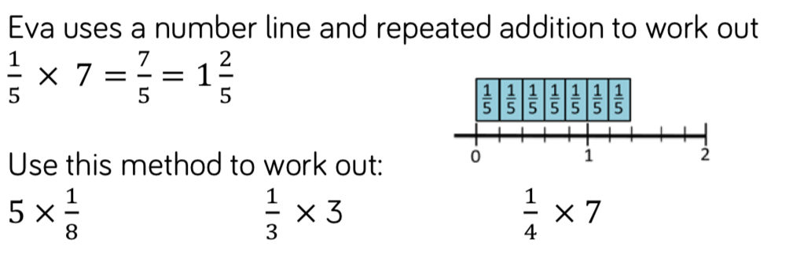**3.**

**ANSWERS:**

1a. 2/3

b. 3/5

c. 6/10

2a. 3/4

b. 6/8 = 3/4

c. 8/10 = 4/5

3a. 5/8

b. 3/3 = 1

c. 7/4 = 1 3/4