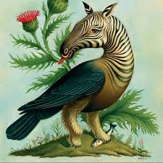
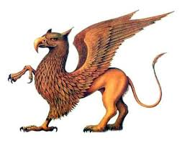
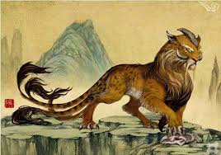
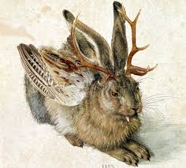

Mythical Creatures

There are many mythical creatures in Harry Potter.
Unicorn - few magical creatures have struck the imagination as deeply as the elegant unicorn. Even in Harry’s wizard world, with so many wonderous beasts, the unicorn is a symbol of the sacred.
Cerberus - ‘Fluffy’ is actually a magical creature from Greek mythology known as Cerberus. He was the sentry who guarded Hades, the underworld, where the souls of the dead go to live for eternity. It was his job to keep all living beings away, and to eat anyone trying to escape.
Centaur - these are mythical beasts with the legs and bodies of horses, but with human torsos, arms and heads.
Dragon - these are probably the best-known magical creatures in literature. Usually dangerous and terrifying, they are often the most challenging foe a hero can face.
Phoenix - this is a magical, eternal bird. When the phoenix completes a full five centuries of life, it dies in a burst of flames and from the ashes rises a new phoenix.

Now it’s time for you to create your own magical creature.
Draw a picture of what you would like it to look like and then write a paragraph to describe it.
Don’t forget to:
- describe the creature’s appearance
- describe how the creature moves
- describe the creature’s actions, thoughts and feelings
- describe the creature’s personality
- include figurative language to up-level your description (similes, metaphors, personification, alliteration).

