**Y4: Let’s talk about cheetahs!**

**What is the first thing most people think of when they think about the cheetah?**

**Watch this clip about cheetahs:** [**https://www.youtube.com/watch/N7e_lDDojas**](https://www.youtube.com/watch/N7e_lDDojas)

Here are some words linked to cheetahs.

Have you heard of any of these?

big cat predator camouflage

savannah accelerate endangered

carnivore feline lair plain cub

Which animal family do cheetahs belong to?

What do you know about any of the other members of the group?

What do they have in common with cheetahs?

Any differences?

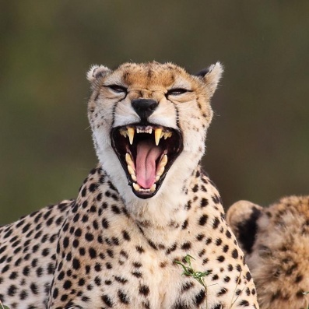

Free Wonder Bubble Cliparts, Download Free Clip Art, Free
        Clip Art on Clipart Library

How do you feel about the fact that the world’s population of cheetahs is on the decline? Why?

Compare your own teeth to those of a cheetah.

Do you have any other questions about cheetahs that you would like to research?

Write the answers to these questions and any other questions you would like to find out in your book.