**Y4: CHEETAHS – Fact finding**

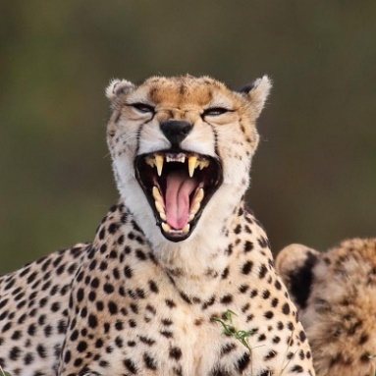Cheetahs are famous for being the fastest of all land animals. They can also accelerate and change direction at speed which makes them very successful predators. They prey typically on the small antelopes and gazelles that roam the open grasslands or savannas of Africa. Despite their fearsome appearance, cheetahs are the smallest of the big cat family. They are easily threatened by other stronger predators, such as lions. They often have to surrender their kill in order to avoid injury in a conflict.

Cheetahs are sometimes mistaken for leopards, because both animals have spots. However, cheetahs are much smaller and leaner than leopards; their spots are more round; and they have long black lines that run from their eyes to their mouth that look like tears.

Cheetahs are a threatened species - every year their numbers get less. This is largely because their habitats - places where they live - have become smaller and fewer, and the animals on which they prey for food have become scarcer.

**Use the text to answer these questions:**

1. Where can you find cheetahs?
2. Why might they not always get to eat what they catch?
3. What species of ‘big cat’ do cheetahs sometimes get mistaken for?
4. Why are there fewer cheetahs alive today than, say, a hundred years ago?

**Extract factual information from the text to complete this Fact File:**

|  |  |
| --- | --- |
| **Name of creature** | Cheetah |
| **Natural habitat** |  |
|  |
|  |
| **Distinguishing features** |  |
|  |
|  |
| **Animals they hunt** |  |
|  |
|  |
| **Threats to survival** |  |
|  |
|  |
| **Interesting fact** |  |
|  |
|  |