**Y5: Let’s talk about hummingbirds!**

**Have you ever seen a hummingbird in real life or in a wildlife documentary?**

**Watch this clip:** <https://www.youtube.com/watch?v=fRw3zaV5ynE>

Here are some words linked to hummingbirds

Have you heard of any of these?

nectar pollinate hover dart

bill metabolism heartbeat species

Why do you think the hummingbird got its name?

Free Wonder Bubble Cliparts, Download Free Clip Art, Free
        Clip Art on Clipart Library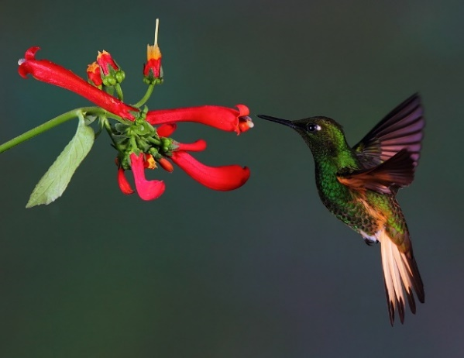

How might these words and phrases be used to describe a hummingbird?

backwards smallest fascinating

1200 times a minute

4.2% of its body weight

What shades of green and purple would you use to describe this hummingbird?

A nickname for hummingbirds is ‘flying jewels’. Why does this appear appropriate?

Think about the common characteristics of birds.

Is an ostrich a bird?

What could you say about an ostrich in comparison to a hummingbird?

Do you have any other questions about hummingbirds that you would like to research?

Write the answers to these questions and any other questions you might have into your book.