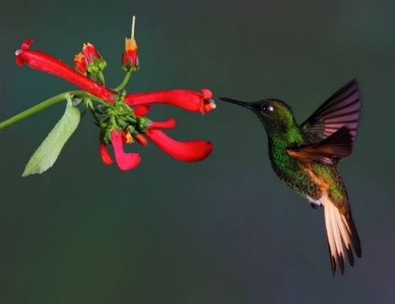**Y5: HUMMINGBIRDS – Fact Finding**

Hummingbirds are the smallest of all birds. They get their name from the humming sound their wings make. Flapping at high speed allows them to hover and dart from flower to flower. They feed purely on nectar, and different species of hummingbirds have evolved different shaped bills depending upon the shape of the flower from which they sip nectar. Many flowers depend upon hummingbirds to pollinate them, rather than insects.

There are more than 340 species of hummingbirds. They are found only in the Americas, mainly Central and South America. They usually live for an average of 3 to 5 years, although some species have been known to live for up to 12 years. The smallest known hummingbird is the Bee hummingbird of Peru. It weighs less than a penny and its nest is the size of a walnut! The feet of a hummingbird are so tiny that they are only used for perching rather than walking or hopping.

Hummingbirds have the fastest metabolism of any bird or animal in the world. They need to eat their body weight or more in a day. A hummingbird can starve to death in a few hours if they don’t eat. They have a really fast heartbeat. It can beat as much as 500 times per minute.

**Use the text to answer these questions:**

1. Why are hummingbirds so called?
2. In what way are hummingbirds important for plants?
3. In which country would you find the smallest species of hummingbird?
4. The human heart beats up to 100 beats per minute. How many times faster is that of a hummingbird?

**Extract the factual information from the text to complete this Factfile:**

|  |  |
| --- | --- |
| **Name of creature** | *Hummingbird* |
| **Where found** |  |
| **Average life span** |  |
| **Main food source** |  |
| **Number of known species** |  |
| **Interesting fact** |  |

Can you find out any additional information about hummingbirds not covered here?