Mathematics
Mathematics Appendix 1: Examples of formal written methods for addition, subtraction, multiplication and division
This appendix sets out some examples of formal written methods for all four operations to illustrate the range of methods that could be taught.
For multiplication, some pupils may include an addition symbol when adding partial products. For division, some pupils may include a subtraction symbol when subtracting multiples of the divisor.
Addition and subtraction
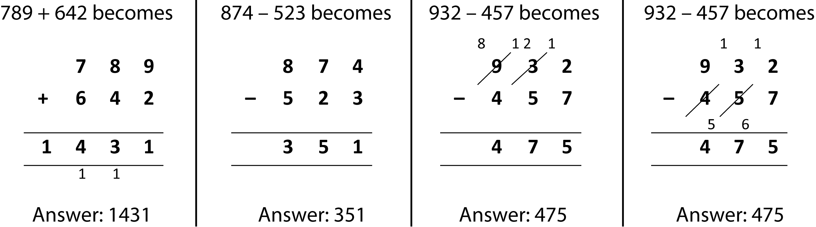

Short multiplication
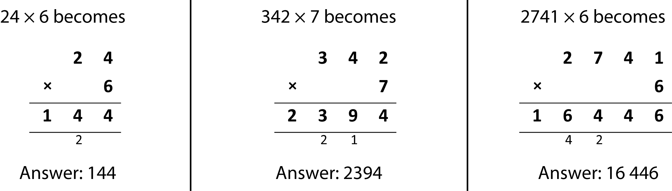

Long multiplication
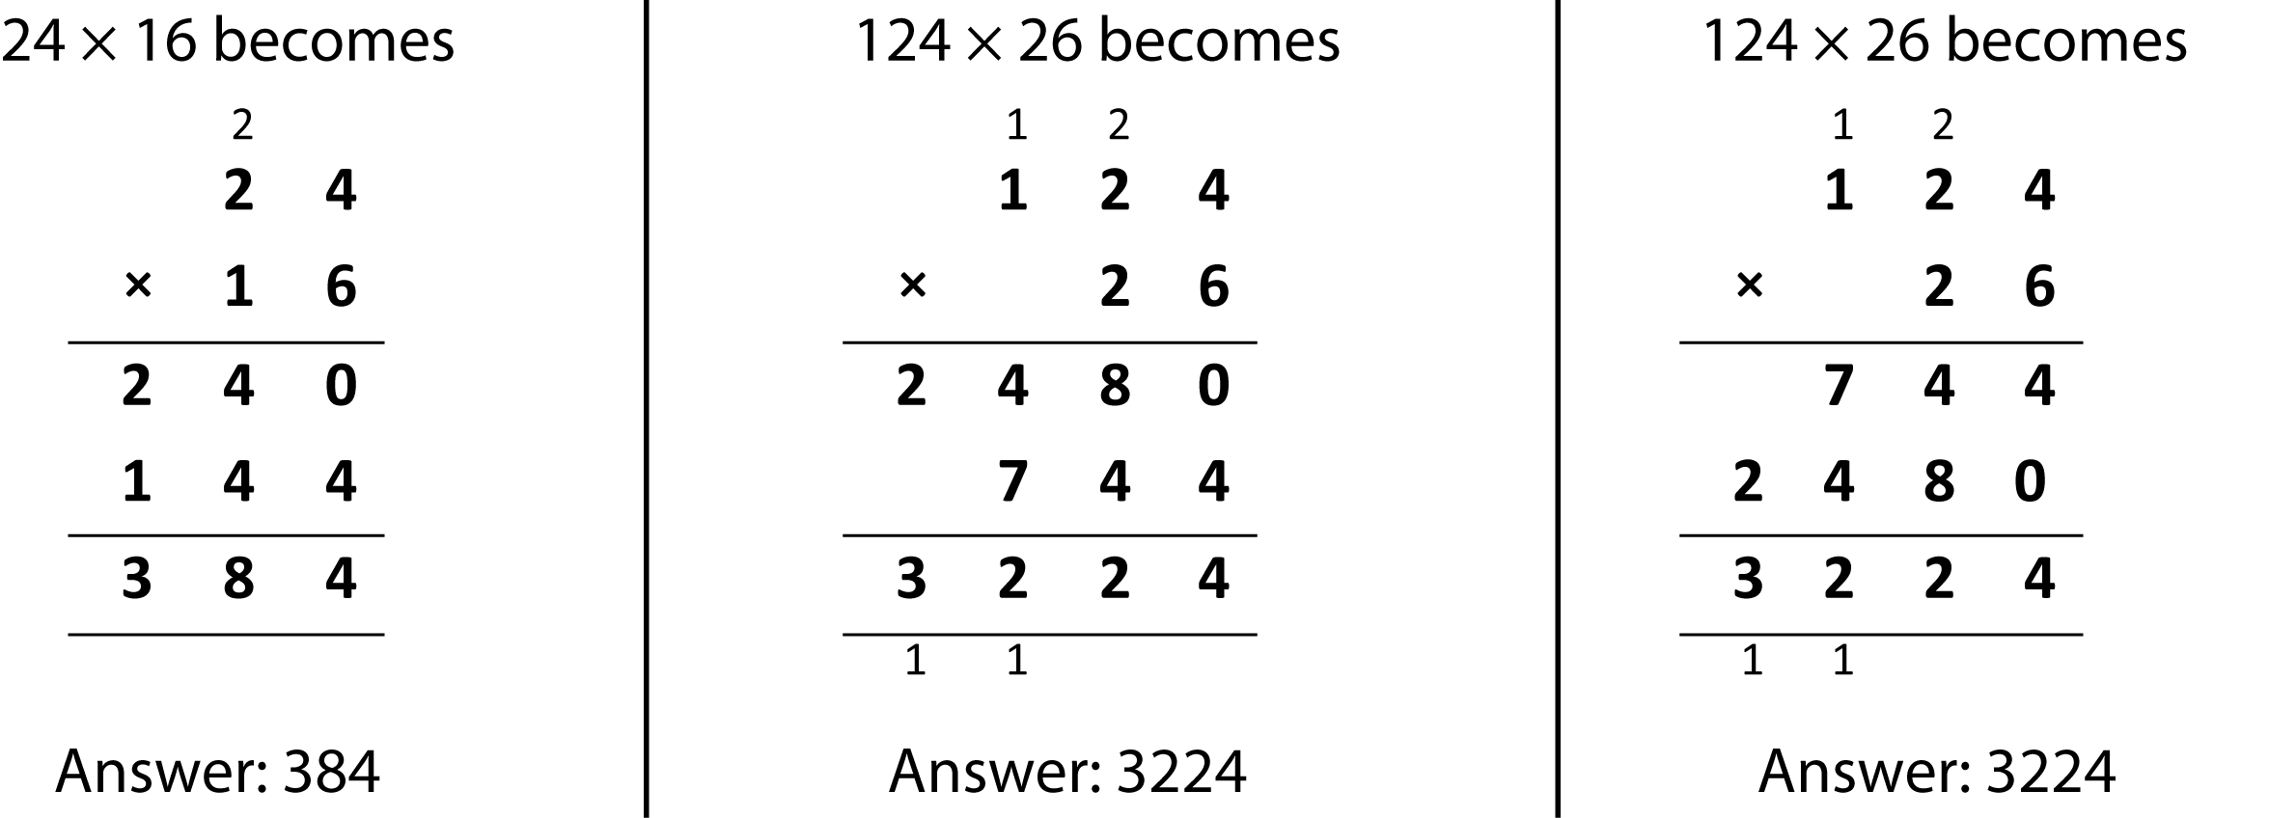

Short division
