Clothing

The clothes that the Maya wore, helped to show how important the person was. Most men and women wore simple clothes. Men would wear a loincloth and cloak, whilst women wore a simple dress.

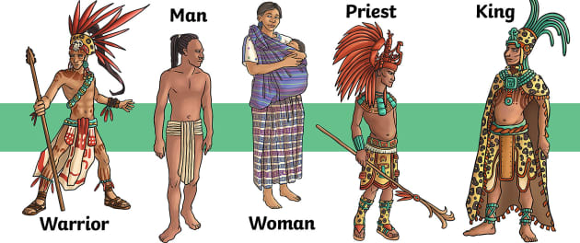Wealthy and important Maya often wore animal skins and highly decorative headdresses. They would also wear jewellery made from jade (a precious stone).

The clothing worn by the Mayans depended on the region they lived in and their social status.

The wealthy Mayans wore colourful clothing made from animal skins.

Wealthy Mayans also wore feather headdresses and fancy jewellery. The Maya loved to wear large hats and headdresses. The more important the person, the taller the hat they wore!

Farmers wore much simpler clothing. The men often wore loincloths while the women wore long skirts. Both men and women would use a blanket called a manta to wrap around their shoulders when it was cold.

**Food**

The Maya civilisation developed new farming techniques to help them grow more crops. Their main crop was maize, but they also grew root vegetables, avocados, squash and beans. Maize made up 80% of their diet. They made tortillas, beer and a type of porridge with the maize. The Maya also grew cocoa and chillies.

The most important food that the Mayans ate was maize, which is a vegetable like corn. They made all types of food from maize including tortillas, porridge, and even drinks.

Other staple foods included beans, squash, and chillies. For meat the Mayans ate fish, deer, ducks, and turkey.

The Maya introduced the world to a number of new foods such as tomatoes, sweet potatoes, black beans and papaya.

The most interesting food the Mayans introduced was chocolate from the cacao tree.

The Maya considered chocolate to be a gift from the gods and used cacao seeds as money.

**Cities**

Historians have discovered several cities built by the Maya, including Chichen Itza, Palanque, Copan and Tikal. They were the first large cities to be built in America. These cities were incredible and had many important buildings, palaces and temples. Pyramid-shaped temples had a shrine at the top, with a staircase on each side of the pyramid leading to this. Each city also had a 'pok a tok' court. Pok a tok was a popular Maya ball game, which involved teams of players competing to put a ball through a stone hoop.

Most ordinary Maya people lived in small and simple homes on the edge of cities. They were made of bricks or wood and had a thatched roof. These homes were often built on a raised platform, made of mud or stone, to protect the building during floods.

El Mirador   
El Mirador was one of the first large city-states of the Maya civilization. It is thought that, at its peak, over 100,000 people lived in the city. The central center of the city covered ten square miles and had over a thousand buildings. Archeologists have found three large temple pyramids: El Tigre (180 feet tall), Los Monos (157 feet tall), and La Danta (250 feet tall). The La Danta temple is considered one of the largest pyramids in the world by total volume.

El Mirador thrived from 6th century BC up to the 1st century AD. It was at its peak around the 3rd century BC. Archeologists think that the city was abandoned around 150 AD and then people moved back in several hundred years later around 700 AD.

Kaminaljuyu

Kaminaljuyu was a major city-state located in the Southern Mayan Area in the Guatemala highlands. The city was occupied for around 2000 years from 1200 BC to 900 AD. The city was a major trade location for products such as cacao, fruits, pottery, and obsidian.

Tikal

Tikal became one of the most powerful city-states in the history of the Maya civilization during the Classic period of Maya history. The city was large and had thousands of structures including six large pyramids. The tallest pyramid is called Temple IV at over 230 feet high. The city likely had between 60,000 and 70,000 inhabitants during its peak years.

Teotihuacan

Teotihuacan wasn't necessarily a Maya city-state, but was a major city-state located in the Valley of Mexico during the time of the Maya civilization. It was so powerful that it influenced Maya culture, trade, and politics during the Classic period.

Caracol

Caracol began as a client state to the powerful city-state of Tikal. It was located in what is now the Cayo District of the country of Belize. At around the year 600 AD, Caracol broke away from Tikal and became a power city-state of its own. The city at its peak was much larger than the capital city of Belize is today. It covered around 200 square kilometers and may have had a population as large as 180,000.

Chichen Itza

Chichen Itza was the dominant Maya city-state during the end of the Classic period and the Post-classic period. It is the home of many famous structures including:

* El Castillo - A pyramid and temple built to the Maya god Kukulkan. It is around 98 feet tall.
* Great Ball Court - The largest of several ball courts in Chichen Itza, the Great Ball Court is 551 feet long by 230 feet wide. The walls on each side of the court are 26 feet tall. Temples of the Jaguar are built into the side of the court.

Temple of the Warriors - This temple is a large pyramid with four platforms and an impressive temple on the top. Two sides of the temple are covered with around 200 columns which were covered with a roof system during the time of the Maya.

Many of these cities can be visited today. Some of them, such as Chichen Itza and Tikal, are considered UNESCO World Heritage Sites.

Around 1.2 million people visit the Chichen Itza site each year. Archeologists have found at least thirteen different ball courts built in the city of Chichen Itza.

Other important Maya city-states include Coba, Uxmal, Mayapan, Tulum, Palenque, and Kabah.

Palenque was once known as the "Red City" because its buildings were all painted red.

Much is known about the kings of Tikal including some of their interesting names such as Jaguar Paw, Curl Head, Shield Skull, and Double Bird. The city was also ruled by women several times.

**Numbers**

The Maya had a good understanding of numbers and they developed a complex number and counting system which was advanced for their time. They were one of only two cultures in the world to develop the concept of zero and this allowed them to develop a place value system where a zero could act as a place holder in large numbers. This enabled the Maya people to distinguish between numbers like 23 and 203, where the placement of the zero determines the value of the digit 2 as 200. This is a very important concept which many civilisations did not understand until much later than the Maya.

The Maya people used symbols to represent their numbers.

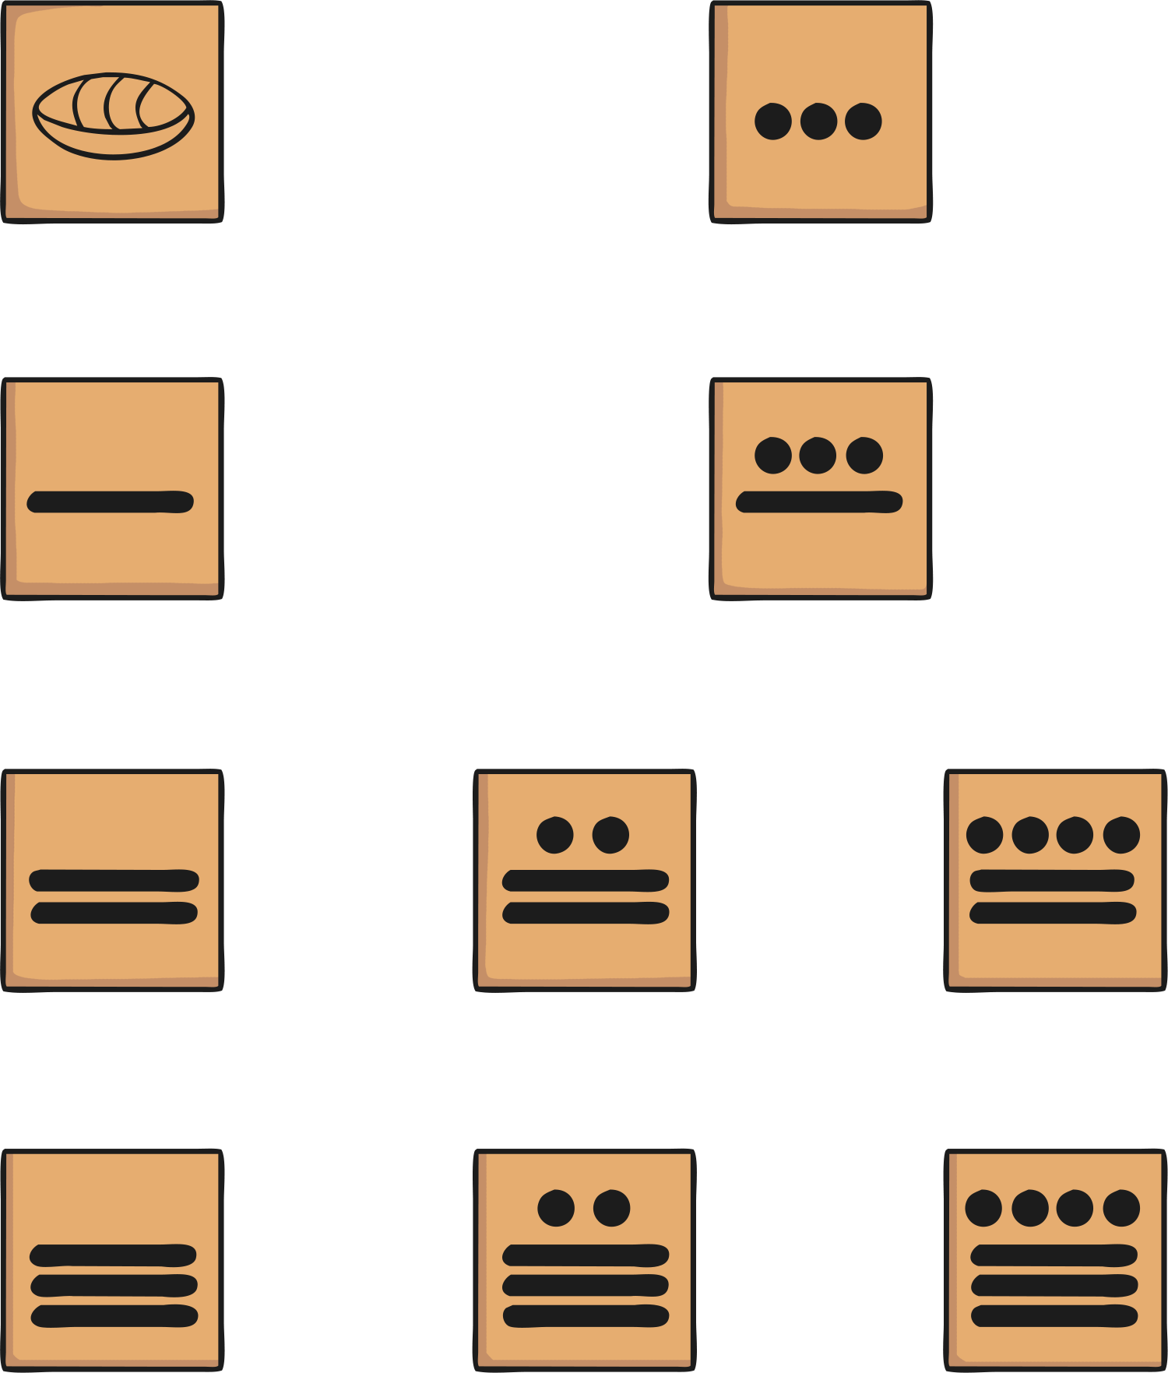

The Maya people used just three symbols in their number system. These are thought to represent items that the Maya people might have first used to count with such as pebbles, sticks and shells.

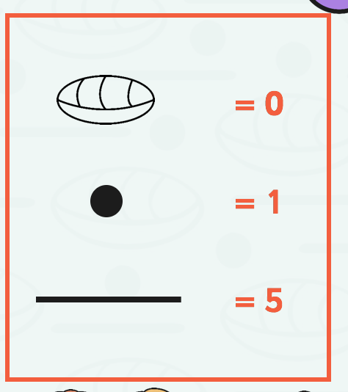

=20

=18

=11

=7

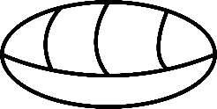

**= 7**

**= 11**

**= 18**

**= 20**

**Main social groups during the Mayan period and how they lived, including looking at daily life for most Mayans.**

**These groups are the noble, peasants/ farmers and slaves.**

**Noble people**

**They were the only members of society that could read and write. They carried out all the decisions of the ruler and ran the city.**

* **They watched over the temples being built**
* **They collected taxes**
* **They led the armies**
* **Wore fancier clothes including gold jewellery and skins of jaguars**

**Peasants’farmers**

**Did most of the farming.**

**They grew corn.**

**During the growing season the men had to spend most of the day in the field.**

**They farmed with wooden hoes.**

**When they weren't farming they were helping build the pyramids.**

**They were allowed to go to royal weddings.**

**They served as soldiers during war times.**

**Slaves**

**The slaves that had a higher rank "got" to be sacrificed to the gods.**

**Some free people became slaves by not handling their business (not paying bills).**

**Some slaves were born into slavery.**

**Slaves were usually not treated poorly.**

**Slaves were not free to come and go as they pleased.**

**Some slaves lived better lives than peasants depending on which job they had and where their masters lived.**

**Homes**

If you were a Mayan noble or king you lived inside the city in large palaces made from stone.

Mayan farmers lived in huts outside the city near their farms. The huts were usually made from mud, but were sometimes made from stone.

They were single room homes with thatched roofs. In many areas the Maya built their huts on top of platforms made from dirt or stone in order to protect them from floods.

Entertainment

Although much of the Maya life was spent doing hard work, they did enjoy entertainment as well.

A lot of their entertainment was centred around religious ceremonies. They played music, danced, and played games such as the Maya ball game.

Sometimes the ball games that the Maya played were part of a religious ceremony. The losers were sacrificed to the gods.

The Mayans had hundreds of different dances. Many of these dances are still practiced today. Some examples of the dances include the Snake dance, the Monkey dance, and the Dance of the Stag.

**Hunting**

The Maya did not have domesticated animals, like pigs, sheep and cows. Instead they hunted wild animals, such as deer and tapir.

To hunt wild animals and fish, the Maya used:

slingshots or blowpipes that fired darts

bone hooks on fishing lines and nets weighed down with stones for catching fish

built dams to create pools to trap fish, which they would then paralyse with the poisonous crushed root of a Balche tree

set snares on paths used often by animals

**Writing – Hieroglyphs and Codices**

The Maya used hieroglyphs to represent sounds as well as ideas, which allowed them to write in sentences like we do.

The Maya used writing to:

write and record stories and myths

write religious books

record the events of their rulers’ lives

write thousands of books

**Number system**

**The Maya had a number system that used a symbol for zero and used place value (this was very rare at the time).**

**The Maya used their number system to:**

* **keep track of time in their calendars**
* **calculate debts and credits**

**make astronomical calculations**

**Astronomy and calendars**

The Maya were greatly interested in astronomy and made a number of very accurate observations and calculations.

They:

calculated that a year was 365 days

calculated that the Moon took 30 days to orbit the Earth

studied celestial bodies for religious reasons

were able to use their knowledge to plan ahead e.g. for when to plant different crops and when to have festivals and ceremonies

**Gods and Religion**

The lives of the ancient Maya centred around their religion and gods of nature.

The Mayans believed in many gods and goddesses.

They believed that priests could talk to Gods. As a result, Mayan priests had incredible power.

Priests were the most powerful people in the Mayan civilisation.

They decided nearly everything in daily life. They decided when to plant, when people could marry and who to sacrifice.

They worshipped the gods of nature every day.

Some of their gods included the God of Rain, the God of Maize and the God of Sun.

Without the help of these important gods, there would be no crops and everyone would starve.

The most important deity was the supreme god Itzamná, the creator god, the god of the fire and god of the earth.

Another important Maya god was Kukulcán, the Feathered Serpent, who appears on many temples.

Also important was Chac, a hooked-nose god of rain and lightning.

Each god had both a good and evil side.

All of the men, but none of the women, used mirrors. In the ancient Maya world, looking into a mirror was an act of courage. The Maya believed that monsters from the Place of Awe could reach through the mirror, and yank you into the Otherworld.

The Mayas believed in an afterlife. Nobles were buried in tombs while commoners buried their dead inside their homes, under the floor. That way, they could live with their ancestors and keep their ancestors easily informed about their daily life.

The Maya world was composed of 3 layers - the Heavens, the Earth and the Underworld, sometimes called the Otherworld or the Place of Awe.

The Mayas conducted many ceremonies to keep the demons, creatures and gods in the Underworld, where they belonged.

The Mayan view of the afterlife consisted primarily of a dangerous voyage of the soul through the underworld, which was populated by sinister gods and represented by the jaguar, symbol of night.

**Masks**

Mayan masks had a wide variety of uses, and the importance of the masks dictated how intricate the designs on various masks were. The most sacred Mayan masks featured complex and delicate mosaics made out of jade.

Other materials used were stone, wood, gold, shell and obsidian (a hard, dark, glass-like volcanic rock)

The Maya used masks for a variety of reasons and occasions. These included:

To adorn (decorate) the faces of the dead

To be worn at important events

To be worn during battle

Battle masks

Some masks which were simple in style were worn by the Mayans during important events like Battles, and usually carved from wood or stone.

These designs focussed on the use of darker colours.

They were worn for one of two reasons:

To protect the wearer during battle by adding spiritual power.

To intimidate the enemy

Event masks

Other masks were designed to be worn during important events such as weddings and birth ceremonies. These masks often used heavenly beings, animals or designs for entertainment purposes.

These masks used amazing designs with bright, vibrant colours painted onto wooden surfaces.

Death masks

Finally, those masks used to adorn the faces of the dead were often seen as the most sacred and therefore were the most elaborate.

These masks used a mosaic patterning of the beautiful greens and blues of the Jade stone to show the close sacred connection between the people and their Gods.

The funeral masks protected the individual while descending into the underworld "Xibalba" in order to defeat the gods of death and to be able to ascend as the Mayan "God of the Corn".