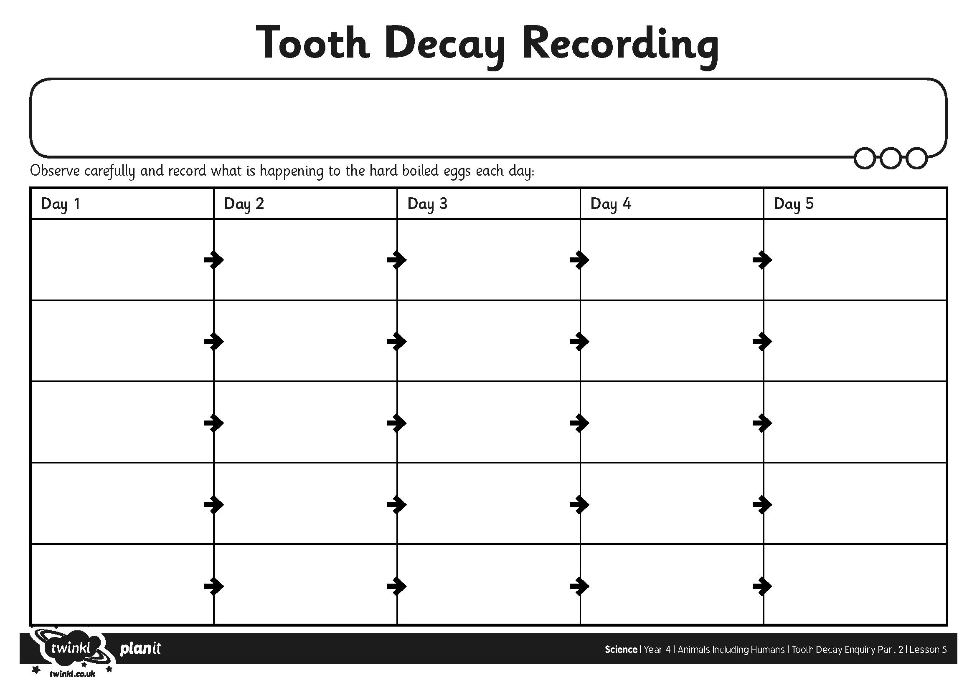
I can make careful observations.
I can appropriately record my results and use them to develop further investigations.

