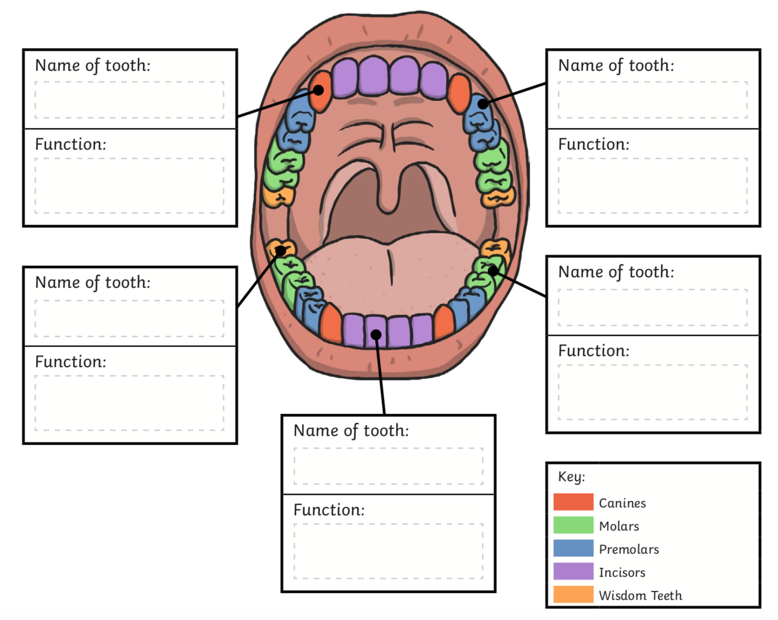

**Use your research to label the diagram.**

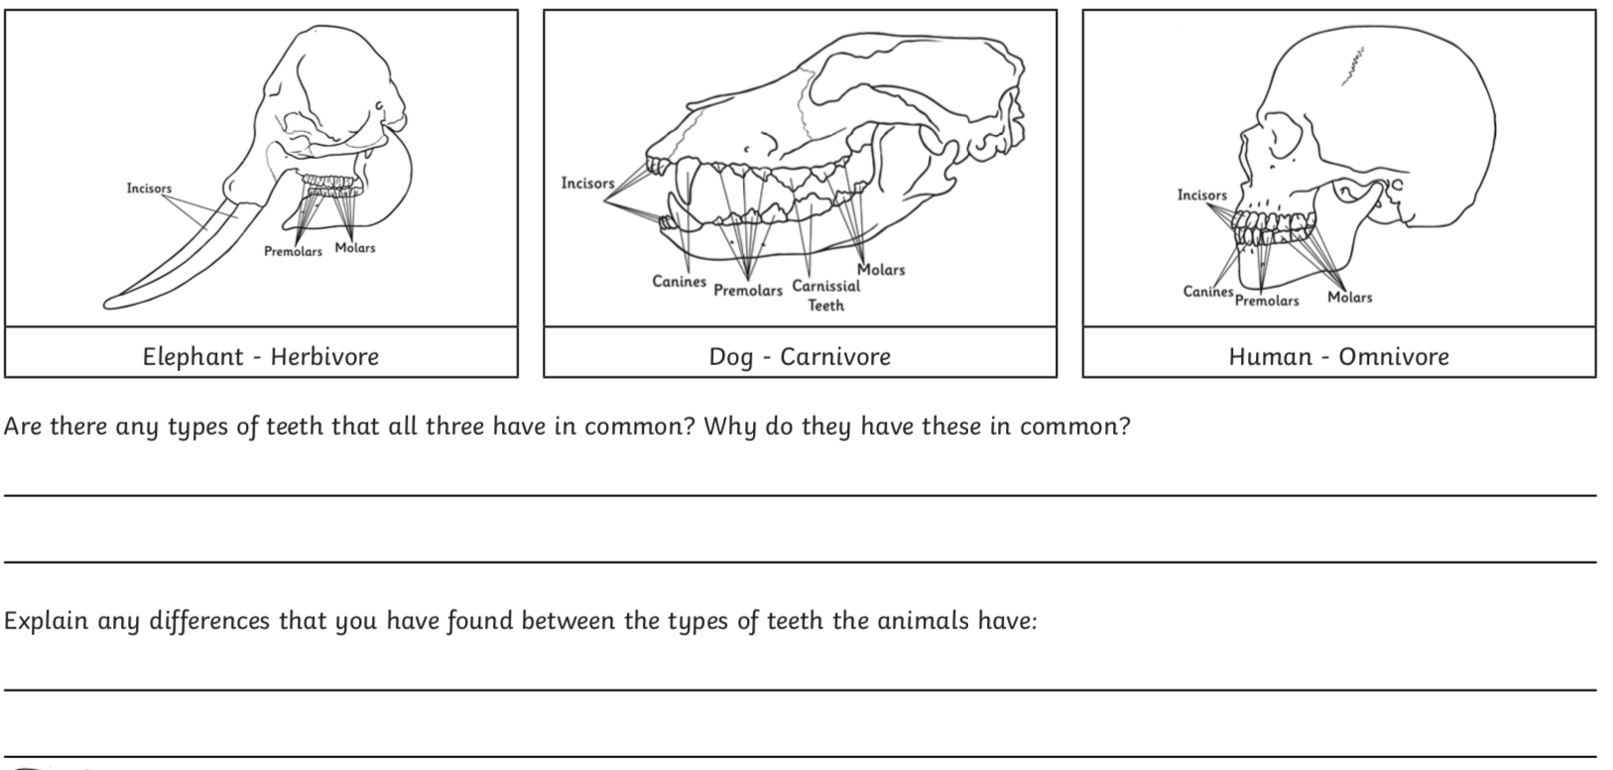

**Use what you have found out from your research to answer these questions.**